* Condition If statement.
* Check the variable

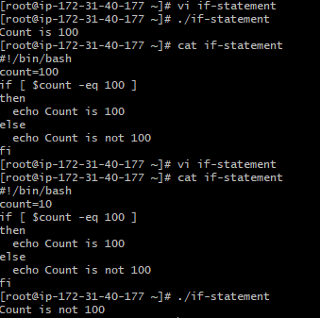

* Check if a file shahnawaz exist.

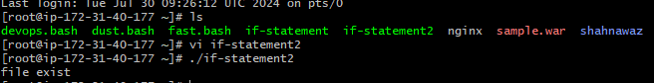

* Check if a variable value is met

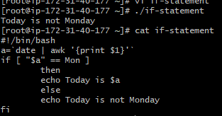

* Check the response and then output.

